Data Analytics 2022

Software Requirements Specification

for

Travellex

Zoe Elliott, Lorraine Sanares

Table of Contents

Introduction 5

Introduction to Research Question 5

Justification for chosen area of research 5

Background information on travel: 6

Formulation of Research Question 7

1.1 Purpose and User Characteristics 7

Task Identification and Gantt Chart 7

Scope 11

Items within scope 11

Items out of scope 11

Operating Environment 11

Functional Requirements 12

Data Requirements 13

Non-Functional Requirements 13

Constraints 15

Collection of Primary Data Methodology 15

7.1 Subjects 15

7.2 The Questionnaire 15

Analysis of Secondary Data 16

Requirements to determine the data reliability : 16

Categorizing Databases 17

Identifying Fields 19

Table 1 – Expenditure 19

Table 2 – Arrivals 19

Table 3 – Border 19

IPO Chart 20

Query Design 20

Site map 21

Justification of Sitemap 21

Design option criteria 29

Evaluation criteria 31

Data Flow Diagram 33

Appendix 34

Database Reference List 34

Other References 34

Web Developer Software 35

Analysis of web developer software 35

Justification of chosen software 36

Testing Plan 36

Structural database testing 36

Testing Formatting and Conventions 36

Testing Queries 37

Testing Formulas and Calculations 37

Testing Dynamic Features 37

Testing Readability 38

User Acceptance Testing Methodology 39

File Management Plan 40

Formatting Documents 40

File Storage 40

File Security Measures 40

41

Proof of file management 41

Database/Spreadsheet Development Journey 42

Tools used 42

Microsoft Visual Basic 42

Visualization Development Journey 45

Figma 45

Tableau 45

Formal Testing Results 46

Dynamic Features (on the visual) 46

Structural Database Testing Results 47

Testing Queries 47

Testing Formatting and Conventions 48

Testing Formulas and Calculations 48

Testing Data Visualisations (Miscellaneous) 49

[Changes to Gantt Chart 50](https://melbournegirlscollege-my.sharepoint.com/personal/san0029_mgc_vic_edu_au/Documents/2022/Data%20Analytics/SAT/docx%20and%20pdfs/SATv3.docx#_Toc112696184)

Changes to solution requirements 51

Changes to databases used 51

Changes to scope 51

Self-Observations (Solution Requirements) 51

Functional Requirements 51

Non-Functional Requirements 52

Data Functional Requirements 54

Reliability Requirements 54

Evaluation Tools 55

Interview Tools 56

Notes from user testing 57

Interview Answers (Summarized): 58

Ratings 59

Evaluation Results 61

Evaluation Criteria Table 61

Analysis of User and Formal Testing Data 62

Assessing the Project Plan 63

Final Remarks 63

# Introduction

## Introduction to Research Question

People travel for various reasons, may that be for business, personal or leisure purposes. Often, it is a way to experience new cultures, explore new locations and get away from the stresses of every-day life. However, the COVID-19 outbreak in 2020 brought travel to a standstill, with most countries implementing international border closures. The impact of this has caused massive job and revenue losses in the travel/tourism industry.

Now with the lift of most travel bans and lockdowns in 2022, people have once again started travelling overseas. However, with due to long periods of lockdown and staying at home, people may find it difficult to budget and plan their trip and may need some aid.

It is important to develop a solution that simplifies the travel planning process; providing essential information to help them prepare before going overseas. Travelling can be an expensive and stressful experience, especially in the post-COVID era, therefore it’s important to make the process easier to encourage people to take more holidays and revive the travel and tourism industry.

## Justification for chosen area of research

**Travel (chosen topic):**

Travel is always a relevant topic in terms of data, with thousands of people worldwide travelling to different countries every year - especially now with the end of the pandemic as we know it. With easy to access and understand data, it would allow people to have a better understanding on when would be the best time to travel to a certain destination, including ways to keep in mind how much it might cost.

**Election:**

With the federal election, party and voting results are extremely relevant, especially once the election is called. The data will be easy to collect and compare with one another, along with having strong corresponding colours users will be able to tell the difference between (e.g., Liberal blue, Greens green). However, the elections can sometimes be swayed depending on current events at that time and can make the data not as reliable as it can be due to the varying factors.

**Vaccination rates:**

While not as relevant as it once was, vaccination rates, especially in terms of the coronavirus have been extremely relevant in the past year. The data is extremely easy to access, with specialised websites with the information available (that Vic coronavirus website is all I can think of). However, the vaccination rates compared to covid cases does differ between covid variants, due to some being more infectious than others, and the first variant did not have to combat the vaccination levels as much

## Background information on travel:

A few subtopics can be derived from the broader topic of travel, such as tourism, migration, and transport. For our research question, we have decided to focus tourism travel.

The tourism travel industry has been severely impacted by COVID-19 in the past two years as global travel restrictions limited overseas arrivals and departures. According to the Australian Bureau of Statistics, the number of international arrivals to Australia in June 2021 had decreased 93.4% when compared to pre-COVID levels in June 2019. However, with the lift of travel bans in Australia 2022, international and domestic travel arrivals/departures have been slowly rising.

The increasing interest on holiday travel is encouraging, however given long periods of staying at home, people may raise questions when travelling their trip. Countries across the globe also have varying restrictions and economic impacts, thus creating uncertainty on factors such as:

* When is the best time of year to go on holiday at the country of choice?
* Are airline expenses significantly higher than pre-COVID levels?
* What are my average expenses during the duration of my visit?
* What are the current restrictions in that country?

These questions pose for an information need, and a solution could be created that synthesizes all the information into dynamic visuals.

|  |  |  |
| --- | --- | --- |
| **Broad Topic** | **Social impact of travel bans/COVID-19** | **Potential Value** |
| Relevant events | International border closures | Caused a significant economic loss for the travel and tourism industry  Allows exploration of the influence this could have on future travel prices. |
| Relevant groups/individuals | Travelers  Employees in the travel industry | Could explore past travel data to explore demographics à determine who is more likely to travel |
| Sub-issues | Travel bubbles  Bans on certain countries  Job losses  Human rights | Might be useful highlight the varying restrictions across countries  Can inform travellers of their destination country’s political stance/relationship with Australia |

## Formulation of Research Question

From the background research, we can derive the research question:

COVID-19 has had a significant impact on the travel industry between 2020-2021. Considering the new regulations and restrictions, what are common traits between the countries that are the most suitable place to travel, and how would this influence/aid travellers when planning their trip in the future?

## Purpose and User Characteristics

The solution will be designed to suit users who want to acquire information based on travelling to various countries throughout the world, preferably through a designed website.

The users will most likely be people wishing to travel abroad on a budget, and the website will be able to assist with that information

User classes:

* Middle class individuals/families
* People living in Australia (website is designed for users to be based in Australia)

# Task Identification and Gantt Chart

Analysis

* Graphic solution specification
  + Introduction to research question
  + Solution scope
  + Solution constraints
  + Solution requirements
    - Functional requirements
    - Non-functional requirements

Design

* Solution constraints
  + Functional requirements
  + Non-functional requirements
* Solution design
  + Collection of data
    - Methodology (of collection of primary data)Identify specific data required
    - Analysis of the collected secondary data
      * Identify which data is relevant and irrelevant (provide justification)
* Table/database design
  + Data structure diagrams identifying the types of relationships between data elements
  + Data dictionary to identify field characteristics (data types)
  + Normalisation (how it will be implemented)
  + IPO chart for calculated fields
  + Query design table
  + Validation techniques + justification
  + Visual solution design
  + Storyboards (since its a dynamic solution)
    - A detailed annotated diagram for each board
    - Annotated diagram for each chart/visual
    - Justification for preferred solutions

* Website solution design
  + Site map
  + Mock up/annotated diagram
  + Justification for preferred solution
* Testing plan
  + Formal testing
    - Testing the table/database:
      * Plan bench testing data
      * Create testing tables for:
        + Testing table validation
        + Testing the query selection criteria
        + Testing formulas
    - Testing the visualisation for
      * Media/plugins and hyperlinks
      * Readability
      * Calculations
      * Loading times
      * Browser compatibility
      * Dynamic features
      * Efficiency
      * Effectiveness (refer to textbook p104-106)
  + User acceptance testing methodology
    - Steps the user should take
    - Feedback form
      * Which questions will be asked
* Acquire primary data
* APA reference list

1. Evaluation criteria
   * Create an evaluation criteria table based on the solution requirements
   * Each criteria must be measured in terms of efficiency and effectiveness

Development

1. Key stages
2. Manipulation of data
3. Validation
4. Testing
5. Documentation

Should follow this process for each component of the graphic solution

Evaluation

* Create an evaluation strategy/timeline for each element of the solution
* Collect feedback data (if relevant)

# Scope

## Items within scope

* Travelers are Melbourne based, therefore flights originate from Melbourne Airport
* Can select travel locations to the top 50 most popular countries
* Users can choose the month they wish to travel
* Show the border status of the 50 countries
* Users can view an expenditure breakdown of their country of choice (accommodation, food, transport, etc.)
* Users can compare airfares between Airlines that travel to their country of choice
* All the visuals are access and viewed on a website

## Items out of scope

* Users having the option to select any location
* Users having the option to select a specific day and time they wish to depart
* Selecting other departure locations different from Melbourne Airport
* Expenditure breakdown doesn’t consider prior expenses such as travel insurance, or unforeseen expenses such as theft, health, or disaster emergencies.

## Operating Environment

Data collection

* Microsoft forms – to make the survey

Data manipulation

* Microsoft Excel
  + Extracting data from databases
  + Creating new databases
* Tableau Prep Builder 2021
  + Transforming data
  + Creating data structures

Creating the visuals

* Tableau 2021

Final presentation of solution

The finished visual solution should operate on an online website, using the WordPress as the web host platform. This will allow users to be able to interact with data visualisation much easier than what could be done on a static infographic, along with being able to have custom arrangements of the visual elements. However, if time restrictions become an issue, the visuals will run on Tableau and will be published to their public gallery.

# Functional Requirements

|  |  |  |
| --- | --- | --- |
| No | Requirement/Output | Notes |
| FR01 | **Allows users to select the month they wish to travel to.** | Date ranges between the past ten years to the next ten forecasted years |
| FR02 | **Users can click on the 50 locations to view more details on that country** | As user clicks on a country, there will be an automatic filter function that shows data only for that country |
| FR03 | **Users can view an expenditure breakdown of their selected country** | Expenditure breakdown will show average accommodation, transport, and food costs. |
| FR04 | **Users can compare airfares between three airlines that travel to their country of choice.** | These airlines will be international flights that are operating from Melbourne Airport (Qantas, Jetstar, and Singapore Airlines) and will using past data |
| FR05 | **Show the border status of the 20 countries** | Shows whether it’s open (no restrictions), open with restrictions, or closed. |
| FR06 | **Popup details should appear as user hovers the mouse pointer over a piece of data** | Popup details should present a summary of the data point |
| FR07 | **Hyperlinks to original data sources** | Hyperlinks will be part of a reference list at the bottom of the website page |
| FR08 | **Website can be accessed through organic Google search** | Will need to have to be searched by its domain name |
| FR09 | **Website page can be refreshed** | Refresh speed should be under 3 seconds |
| FR10 | **Easy to use on different technologies** | Website works on multiple devices. (e.g., Phone, tablet, laptop) |
| FR11 | **Compatible with multiple browsers** | Can be accessed on different browsers such as Chrome, Microsoft Edge, Firefox. |

# Data Requirements

|  |  |  |
| --- | --- | --- |
| No | Requirement | Notes |
| ~~FR012~~ | **Number of international arrivals for each selected 50 countries** | Ideally should have data for each month – this will be used to determine the most popular times to travel to that country |
| FR13 | **Average airfares of outbound flights from Melbourne Airport** | Should select data for main Airlines such as Qantas, Jetstar, Virgin, Singapore Airlines |
| FR14 | **Average tourism expenditures from that country** | Ideally should include have different expenditure categories such as accommodation, transport, etc. |
| ~~FR15~~ | **International border status of the 50 countries** | Might be qualitative data. |
| FR16 | **Forecast data of expected international arrivals of each country** | Should have a minimum of 5 years of forecasted data. |

# Non-Functional Requirements

|  |  |  |
| --- | --- | --- |
| **No** | **Requirement** | **Notes** |
| **NFR01** | **UI and visualizations should be clean** | Big short titles, colours that match yet contrast, information that can be understood with some inference |
| **NFR02** | **Is user-friendly** | Users should be able to use all visualization and dynamic visual functions within the first 10 minutes |
| **NFR03** | **Image components should have good resolution** | Should be clear (at least 72 PPI), not pixelated |
| **NFR04** | **Fast component response rate** | Buttons and links should respond withing 1.5 seconds |
| **NFR05** | **Fast website load time** | Website page should load within three seconds |
| **NFR06** | **Primary data stored confidentially** | Preferably the database/spreadsheet holding primary data won’t be accessible through website hyperlinks |
| **NFR07** | **Data is reliable and acknowledged if from other sources** | The data used should have been collected from recent years – perhaps with an exception for years during lockdown |
| **NFR08** | **The information will follow the Australian Privacy Principles** |  |
| **NFR09** | **The graphs will be proportionate to the sizes required** | e.g., the size of the US will not be made uncharacteristically larger unless it is relevant to how the data is shown |

# Constraints

**Economic:**

* No budget is given; therefore, data manipulation/visualization software and website creator tools will have to be free of charge
* Limited time to complete task

**Technical**

* Different operating systems on laptop (macOS and Windows)
* Tableau is only compatible with macOS, not Windows.

**Social**

* Solution developers have limited knowledge of Tableau, Excel, Microsoft SQL, and website development; therefore, it will take time to learn how to use these software

**Usability**

* Accessibility for blind and dyslexic individuals cannot use this graphic solution
* Colour blind individuals should not have problems differentiating colours on the screen

**Legal**

* Must reference secondary data using APA method to avoid legal issues.
* Must adhere to Australian legislation to protect those who are providing primary data
  + Privacy Act 1988
  + Privacy and Data Protection Act 2014
  + Health Records Act 2001
  + Copyright Act 1968

# Collection of Primary Data Methodology

## 7.1 Subjects

Data will most likely be collected from secondary students, since the budget and time constraints limit the variety of our subjects. It is assumed that most participants will have travelled overseas, therefore they will not be provided with much background information about our area of research

## 7.2 The Questionnaire

The survey will be sent out to the participants via a Microsoft Forms link. Upon opening the survey, they will be provided with a consent form, asking if they permit the information that they provide to be used for research purposes. Participants will also be assured that the information that they provide will remain anonymous and unidentifiable.

The questionnaire may contain a variety question types such as Likert scales and dropdown selections. The participants may be asked the following questions related to travel:

|  |  |  |  |
| --- | --- | --- | --- |
| Question | Type | Format | Validation rule |
| At which time(s) of the year have you travelled overseas? | Quantitative | Calendar selection  Manual date input  Must allow multiple entries | Type check  Existence check  Input mask  Range check? |
| During which season to you prefer to travel?  (e.g., summer, autumn, etc.) | Qualitative | Dropdown | Existence check |
| What is average length (in days) of your overseas vacations? | Quantitative | Manual input (numeric) | Type check  Input mask  Existence check |
| How much on average do you spend during your vacation? | Quantitative | Dropdown?  Manual input | Type check  Existence check  Range check |

There is currently no analysis of primary data due to none being collected – survey wasn’t sent out

# Analysis of Secondary Data

## Requirements to determine the data reliability :

|  |  |  |
| --- | --- | --- |
| **Reliability requirement** | **Analysis question** | **Notes** |
| **RR01** | Is the database relevant to the solution requirements? | Data values should contain data within the past 5-10 years |
| **RR02** | Is the database collected from a reputable source? | Source should be a well-respected organization. Ideal if website domain includes (.gov, .org) |
| **RR03** | Is data formatted and stored correctly? | Does it have axis titles? Includes units of measurements? Data values formatted uniformly? |
| **RR04** | Does the dataset include values for all fields? | No missing values, no empty cells? |
| **RR05** | Is the data free from duplicates? | This would indicate that the data is not copied from other sources, nor a mix of other primary data value from different databases |

## Categorizing Databases

|  |  |  |
| --- | --- | --- |
| **Tourism Forecasts** | | |
| **DB01** | File name | National_Tourism_Forecasts_2019 |
| File type | xlxs |
| Source | Tourism Research Australia. (2019). International tourism forecasts {web page}. *National_Tourism_Forecasts_2019.* Retrieved from <https://www.tra.gov.au/International/international-tourism-forecasts> |
| Properties | Data represents Australian Statistics   * Data is given per year * Outbound departures by destination (2000-2028)   + Shows purpose of visit   + Countries of destination: New Zealand, Indonesia, US, UK, Thailand, China, Singapore, Fiji, Malaysia, Hong Kong, other Asia, other Europe, other world. |
| Pros and cons | Pros:   * Shows predicted data for the next 10 years   Cons:   * Limited countries of destination (only 10) * Only show number of Australian residents arriving at that country * Dates are not separated by month |

|  |  |  |
| --- | --- | --- |
| **International arrivals** | | |
| **DB02** | File name | international_airline_activity_opfltsseats_0222_tables |
| File type | xlxs |
| Source | Department of Infrastructure, Transport, Regional Development and Communication. (2022, May 26). International Airlines Operated Flights and Seats {web page}, *international_airline_activity_opfltsseats_0222_tables.* Retrieved from <https://www.bitre.gov.au/publications/ongoing/international_airlines-operated_flights_seats> |
| Properties | Data ranges from 2003-2022   * Data is recorded per month * Number of inbound and outbound flights and seats between   + Australian city-country   + Australian city-region * Number of inbound/outbound flight and seats (month-departure aus city-which airline)   Notes:   * Cannot use this data to calculate totals; may result in double counting (stated in the databases footnotes) * Directly connected vs “same flight number” connection? |
| Pros and cons | Pros:   * Has data for many countries * Separated by month * Has airline data – however doesn’t show airfares   + Could be used to rank airline popularity?   Cons:   * Only records Australian residents – does not show total of international arrivals in that country |
| **DB03** | File name | unwto-inbound-arrivals-data.xlsx |
| File type | Xlxs |
| Source | World Tourism Organisation (no publication date). 145 Key Tourism Statistics {Web page}. *unwto-inbound-arrivals-data.* Retrieved from <https://www.unwto.org/statistic/basic-tourism-statistics> |
| Properties | * Data collected from multiple countries throughout the world * Show total arrivals of inbound tourists, while separating them into overnight, same-day and cruise tourists |
| Pros and cons | Pros   * Collects data from most countries around the world * Updated every year   Cons   * Data is no separated by month |
|  | File name |  |

|  |  |  |
| --- | --- | --- |
| **Expenditure** | | |
| **DB04** | File name | untwo-inbound-expenditure-data |
| File type | Xlxs |
| Source | World Tourism Organisation (no publication date). 145 Key Tourism Statistics {Web page}. *untwo-inbound-expenditure-data.* Retrieved from <https://www.unwto.org/statistic/basic-tourism-statistics> |
| Properties | * Data collected from multiple countries around the world * Separates data into travel costs, transport costs, along with total expenditures |
| Pros and Cons | Pros   * Has a breakdown of expenditure disaggregated by travel, passenger transport   Cons   * Does not explain the difference between travel and passenger transport |
| **DB05** | File name | Not a file database |
| Source | Kayak (2022). *International Travel Restrictions by Country.* Retrieved from <https://www.kayak.com.au/travel-restrictions> {web page}. Retrieved from <https://www.kayak.com.au/travel-restrictions> |
| Properties | * Allows user to see border restrictions of certain countries form home destination |
| Pros and Cons | Pros   * Clear colour contrasts of the levels of restriction * Has other statistics included in the website * Is up to date |
|  |  |  |

# Identifying Fields

## Table 1 – Expenditure

|  |  |  |  |  |  |  |  |
| --- | --- | --- | --- | --- | --- | --- | --- |
| **Field name** | **Data type** | **Size** | **Caption** | **Format** | **Validation** | **Validation text** | **Other** |
| CountryID | Autonumber |  |  |  |  |  | Primary key |
| expCountry | Text |  | Country of destination |  |  |  |  |
| expTravel | Number |  | Travel (flight) expenses | Integer |  |  |  |
| expPasTrans | Number |  | Passenger Transport | Integer |  |  |  |
| expAccom | Number |  | Accommodation | Integer |  |  |  |
| expTotal | Number |  |  | Integer | Required |  |  |

## Table 2 – Arrivals

|  |  |  |  |  |  |  |  |
| --- | --- | --- | --- | --- | --- | --- | --- |
| **Field name** | **Data type** | **Size** | **Caption** | **Format** | **Validation** | **Validation text** | **Other** |
| CountryID | Autonumber |  |  |  |  |  | Primary Key |
| arrCountry |  |  |  |  |  |  |  |

## Table 3 – Border

|  |  |  |  |  |  |  |  |
| --- | --- | --- | --- | --- | --- | --- | --- |
| **Field name** | **Data type** | **Size** | **Caption** | **Format** | **Validation** | **Validation text** | **Other** |
| CountryID | Autonumber |  |  |  |  |  | Primary Key |

# IPO Chart

|  |  |  |
| --- | --- | --- |
| **Input** | **Process** | **Output** |
| Country of choice | Filter | Country of choice |
| - Number of international arrivals to the country  - Tourism expenditure of the country | =expTotal/arrCountry | Average expenditure per person  (expAverage) |
| - Average expenditure per person  - Duration of stay | =avgExpense*durStay | Estimated cost of holiday  (expEstimate) |
| - Filter year visible on graph | Slider: starting year – current year | Custom range of year |

User inputs

* Country of destination
* Hyperlink click to season
* Hyperlink click to expenditure page
* Hyperlink click to tourism summary
* Duration of stay
* Filter movement – year on graphs

Table calculations

* Average expenditure

# Query Design

|  |  |  |  |  |
| --- | --- | --- | --- | --- |
| Field name | Sort | Filter | Calculation | Other |
| CountryID |  |  |  | Hidden |
| nmCountry | Ascending A-Z |  |  |  |
| expTravel |  |  |  |  |
| expPasTrans |  |  |  |  |
| expAccom |  |  |  |  |
| expTotal |  |  |  |  |
| arrCountry |  |  |  |  |
| expAverage |  |  |  |  |
| expAvgValid |  | = True |  |  |
| expEstValid |  | = True |  |  |

# Diagram Description automatically generatedSite map

**Design 1**

## Diagram Description automatically generatedJustification of Sitemap

**Design 2**

Design 1’s navigation structure organises the web pages to branch off from the home page. This means that there may be longer loading times between changes, which might discourage users from using the website.

Meanwhile, design 2’s structure sorts the web pages to only have two branches off from the main page, limiting loading times and allowing users to access information faster as they don’t need to navigate as much.

Overall, using the navigation structure for site 2 would be more efficient and easier to use as a user of the solution

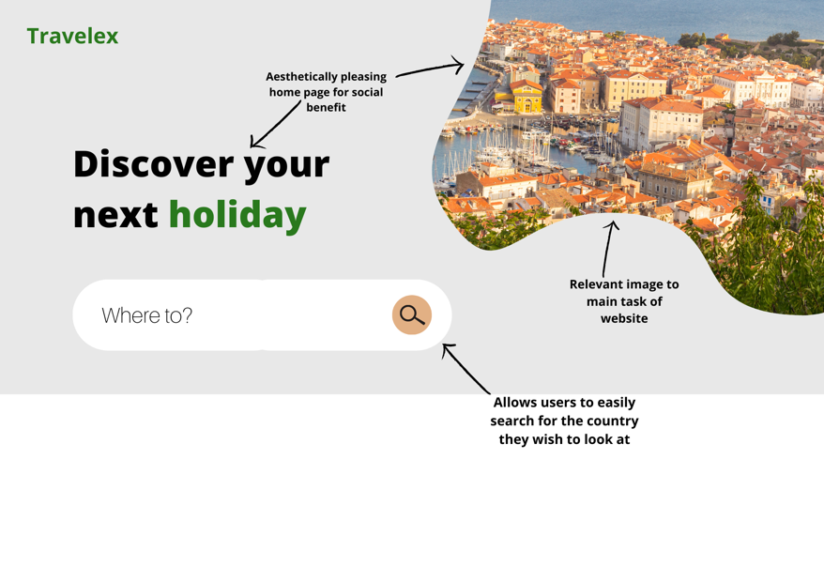

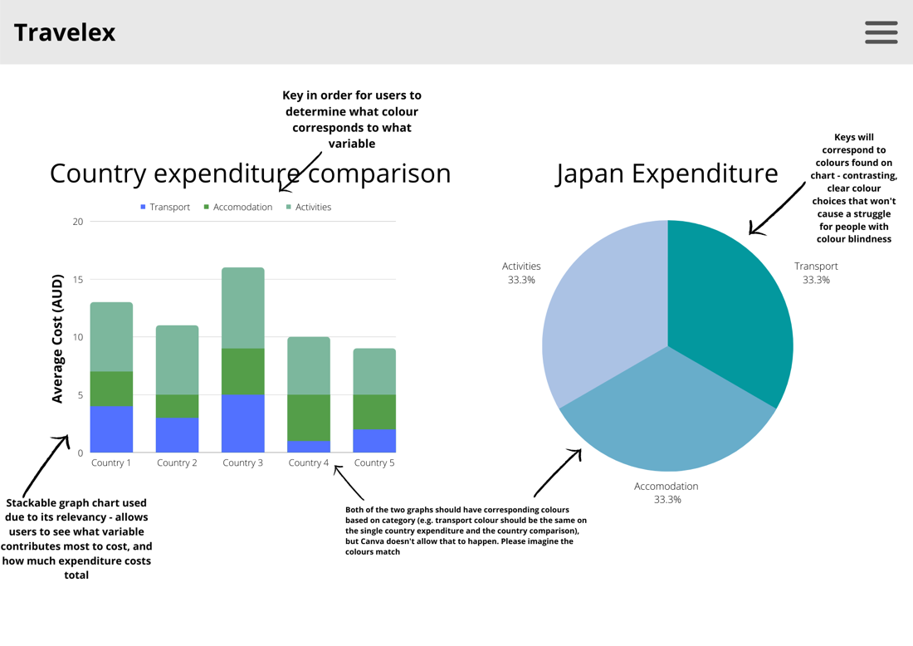

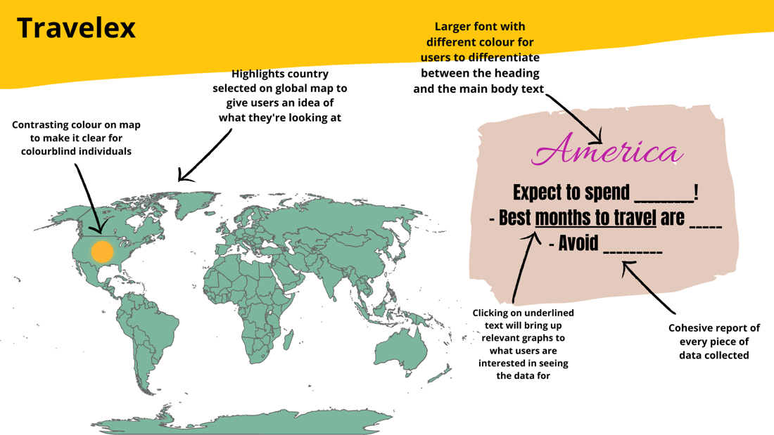

# Design option criteria

|  |  |  |
| --- | --- | --- |
| **Criteria question** | **Design 1** | **Design 2** |
| Is the design solution easy to use (Yes/No, /5) (FR) | Yes, 4/5  *The design allows the user to be able to access different aspects of data amongst certain webpages. A mark has been lost due to the number of different webpages, but the rest is cohesive and easy to use.* | Yes, 4/5  *The design is compact, allowing the user to access all required information on one page. Marks have been lost due to everything being very tightly compacted onto one single page* |
| Is the relevant secondary data easy to view/navigate to (Yes/No, /5) (FR) | Yes, 4/5  *The design keeps relevant secondary data on one webpage, allowing users to access any graphs they wish to see at one time, along with referencing original sources. One mark has been lost due to the graphs not being integrated* | Yes, 2/5  *The design has all the graphs on one page, accessible through underlined links that have relevance to what information is required. Marks have been lost due to the lack of navigation explanation, overcrowding of graph numbers on one page, and lack of referencing original sources* |
| Is it accessible to certain users? (e.g., colour blind individuals) (Yes/No) (FR) | Yes  *Whilst not shown as clearly due to the design being created on Canva, both the graphs and relevant images are designed to have clearly contrasted colours to limit the confusion made from similar colours for those who have vision issues* | Yes  *Same reasoning as design 1* |
| Is the space well balanced? (Yes/No, /5) (NFR) | Yes, 4/5  *The design is split across several webpages, allowing the option for each of the webpage's spaces to be well balanced and not overcrowded* | No, 0.5/5  *The design solution is all crammed onto one webpage, limiting how the space can be well balanced and used. However, before clicking on any extra links it could be argued that the space on the webpage is well balanced* |
| Is the design well formatted? (Yes/No) (NFR) | Yes  *The design is formatted in a cohesive way to make it easier for users to find the information they’re searching for* | Yes  *The design has been set out to keep simple at first, allowing the user to increase the complexity by opening extra graph links if they choose so* |
| Is the design contrasting? (Yes/No, /5) (NFR) | Yes, 3/5  *The design uses a variety of colours that match well aesthetically throughout the solution. However, some webpages have a distinct lack of contrast and colour compared to others, making them look quite bland* | Yes, 4/5  *The design uses a few contrasting colours on the page that all stand out yet blend well together* |
| ***TOTAL*** | ***15/20*** | ***10.5/25*** |

**Design 1 is the better option in comparison to design 2, meaning that design 1 will most likely be the one included in the solution. This is due to the flow of the webpages within the website, the rate on how easy it is to use and the balance between space and information on the website compared to that of design 2.**

# Evaluation criteria

• Does the solution allow users to select the country they wish to travel to? **Yes/No**  
*Measured by checking if users can either successfully search in the country of their choice, or picking it from a list of options*

• Is the solution accessible on multiple devices? **Yes/No**  
*Measured through whether the solution can be used with the same goal in mind on multiple devices, such as phone or laptops*

• Does relevant data that links to the solution have accessible links? **Yes/No**  
*Can be shown through working links placed on webpages, that have relevant data to what’s being shown on the webpage*

• Is the data collected from secondary sources reliable? **Yes/No**  
*Measured through the reliability of the company/organisation where the original data is collected from*

• Is the data collected from secondary sources accurate? **Yes/No**

*Measured through cross referencing with other sources and checking for any outliers in the data*

• Is the solution easy to use? **Yes/No**

*Measured through user testing and their responses based on the test*

• Are the data sources used and user data confidential? **Yes/No**

*Shown through complying with relevant Australian Privacy Principles*

• Does the data collected and used follow the Australian Privacy Principals? **Yes/No**  
*Shown through complying with relevant Australian Privacy Principles*

• Are the images and graphs used proportionate to the size of the website? **Yes/No**

*Shown through the overall aesthetic feel of the website, making sure it doesn’t feel too crowded*

• Is the solution efficient (e.g., the website loads quickly)? **Yes/No**

*Measured through the rate it takes to load webpages throughout the website*

**Graphics rating - /5**

*Measured through an overall analysis compared to certain results relating to graphics from the Boolean questions*

**Efficiency rating - /5**

*Measured through an overall analysis compared to certain results relating to efficiency from the Boolean questions*

# Diagram Description automatically generatedData Flow Diagram

# Appendix

## Database Reference List

* + Tourism Research Australia. (2019). International tourism forecasts {web page}. *National_Tourism_Forecasts_2019.* Retrieved from <https://www.tra.gov.au/International/international-tourism-forecasts>
  + Department of Infrastructure, Transport, Regional Development and Communication, (2022, May 26), International Airlines Operated Flights and Seats {web page}, *international_airline_activity_opfltsseats_0222_tables.* Retrieved from <https://www.bitre.gov.au/publications/ongoing/international_airlines-operated_flights_seats>
  + World Tourism Organisation (no publication date). 145 Key Tourism Statistics {Web page}. *unwto-inbound-arrivals-data.* Retrieved from <https://www.unwto.org/statistic/basic-tourism-statistics>
  + World Tourism Organisation (no publication date). 145 Key Tourism Statistics {Web page}. *untwo-inbound-expenditure-data.* Retrieved from <https://www.unwto.org/statistic/basic-tourism-statistics>
  + Kayak (2022). *International Travel Restrictions by Country.* {web page}. Retrieved from <https://www.kayak.com.au/travel-restrictions>

## Other References

* + Willet, N. (2022, June 21). *Best Website Builder 2022: We’ve Reviewed the 11 Best.* {blog post} Retrieved from data [The 11 Best Website Builders of 2022 (websitebuilderexpert.com)](https://www.websitebuilderexpert.com/website-builders/)

# Web Developer Software

## Analysis of web developer software

|  |  |  |
| --- | --- | --- |
| **Web developer** | **Pros** | **Cons** |
| **WordPress**  Recommendation: 3.5 | Customisable with code  Prior experience with WordPress  Flexible use  Allows plugin options | Not built for websites that aren’t blogs |
| **Wix**  Recommendation: 4.8 | Large number of available templates to use on website  Easy to use  Gives option of converting laptop versions to mobile  Allows multilingual options, either manually or automatically | Unstructured editor – can cause sync issues between desktop and mobile version  Editor can be “overwhelming”  Slightly limited – some available options behind paywalls  Wix ad constantly on top of screen on free trial |
| **Squarespace**  Recommendation: 4.7 | Ideal for creative portfolios (can technically be considered)  Labelled as having “outstanding” templates | Only free trial, no option for using Squarespace for free, for an unlimited amount of time  Limited integration with third party integrations, makes inclusion of relevant graphs difficult  Can have a “learning curve” |
| **Tableau Public Gallery** | Allows designers to share their dashboards  No fees  Can upload dashboards directly from Tableau software | Cannot perform organic search on Google  Need to share link |

Recommendation number is based off user reviews found on websitebuilderexpert  
[The 11 Best Website Builders of 2022 (websitebuilderexpert.com)](https://www.websitebuilderexpert.com/website-builders/)

## Justification of chosen software

Chosen Software for website: Tableau (Public Server)

* Can directly upload dashboard from the project workbook, thus eliminating website development time
* Limited knowledge in other web dev software/platforms

# Testing Plan

These are the table designs for the testing phase

## Structural database testing

|  |  |  |  |  |
| --- | --- | --- | --- | --- |
| What was tested | How it was tested | Expected Result | Actual Result | How it was fixed |
| Check for presence of Primary and Foreign Keys | Through observation | Primary key: there should a common field between all sheets  Foreign keys: field names should be different between each sheet |  |  |
| Data type of the primary key and the corresponding foreign keys are the same in the two tables | Through observation | Month = “Time”  Country_Name = “General”  Year = “Time”  Expenditure = “Currency”  Precipitation = “Number” |  |  |

## Testing Formatting and Conventions

|  |  |  |  |  |
| --- | --- | --- | --- | --- |
| What was tested | How it was tested | Expected Result | Actual Result | How it was fixed |
| Naming conventions have been followed for all fields | Observation | All fields should follow a combination of snake and camel casing naming conventions |  |  |
| Table formatting is consistent throughout all sheets | Observation | All tables should have:  A black header, primary in the first column, field titles in bold |  |  |

## Testing Queries

|  |  |  |  |  |
| --- | --- | --- | --- | --- |
| What was tested | How it was tested (data) | Expected Result | Actual Result | How it was fixed |
| A-Z sort on country name | Through observation | All countries should be in alphabetical order (A-Z) |  |  |
| Filter function (per column) | All data will be unselected, then  Approach 1: Each checkbox will be individually clicked  Approach 2:  2-3 boxes will be selected at a time | The column should only show data clicked by the checkbox. |  |  |

## Testing Formulas and Calculations

|  |  |  |  |  |
| --- | --- | --- | --- | --- |
| Input | Process | Expected Output | Actual Output | How it was tested |
| Expenditure (USD) | =Expenditure (USD) * 1.44 | Expenditure (AUD) |  |  |
| Exp_Transportation, Exp_Accomodation, Exp_Food, Exp_Entertainment | = SUM(Exp_Transportation, Exp_Accomodation, Exp_Food, Exp_Entertainment) | Expenditure Total |  |  |

## Testing Dynamic Features

|  |  |  |  |  |
| --- | --- | --- | --- | --- |
| What was tested | How it was tested | Expected Result | Actual Result | How it was fixed |
| Page navigation buttons | Each button will be clicked on each page/dashboard to see if the user is taken to the intended page | “Border Status” 🡪 border status page  “Budget Calculator” 🡪 budget calculator  “Best time” 🡪 best time  “Home Page” 🡪 home page |  |  |
| Drop down menu on home page | Multiple countries will be selected from the dropdown menu | The map should zoom into the country selected in the dropdown |  |  |
| Pop up details | Mouse will be hovered over the country | Pop up details should show a summary of the country when mouse is hovered over the country |  |  |
| Budget limit | The slider will be set to different limits and the value of the lowest and largest value will be checked if within the limit | The slider should only show the countries with daily expenses within the set limit |  |  |
| Cost breakdown number displays | A country of the bar chart will be selected, and the expense breakdown numbers were compared to the database values | Should change/represent the correct expense breakdown of the selected country when it is clicked on the bar chart |  |  |
| Month dropdown filter (on ‘best time’ page) | All months were clicked, and the ‘Country Rainfall Comparison’ chart was observed | As a month is selected, the ‘Country Rainfall Comparison’ chart should change, and the order precipitation maintains its small to large arrangement |  |  |
| Country name filter | 5 countries were selected, and the ‘Monthly Rainfall’ chart was observed | As a country is selected, the ‘Monthly Rainfall’ chart values should change |  |  |

## Testing Readability

|  |  |
| --- | --- |
| Criteria | Tick |
| Is the text large enough to read comfortably on a small device? |  |
| Is contrast optimal, or at least satisfactory? |  |
| Is the typeface a readable size? |  |
| Are line or paragraphs of a good length? |  |
| Is text alignment attractive and readable on the page? |  |
| Are the spelling, punctuation, and grammar, correct? |  |
| Is the vocabulary appropriate and inoffensive? |  |
| Is expression clear and unambiguous? |  |
| Are headings clear, and do they divide content into logical sections? |  |
| Are all the charts appropriately labeled? |  |

# User Acceptance Testing Methodology

Users will be asked to explore the visual solution, and their actions will be observed. Users should voice any questions and suggestions they have about the solution as they test it.

Afterwards, the user will be interviewed a series of questions relating to the ___. They will also rate (out of 5) certain aspects of the solution.

**Two different user approaches:**

1. The person has an idea of where they want to go, and they need to find out travel information about that country

**Purpose**: To check if the solutions functions work and the information is successfully conveyed

1. The person is indecisive/uncertain of which country to travel to, therefore will use the solution to determine the most suitable place to visit.

**Purpose:** to determine if the solution is a competent tool in aiding decision making.

**Objectives of approach 1:**

1. Identify the country they intend to visit
2. Find out the border status of that country
3. What is the daily expense of that country?
4. Which month is the best time to visit that country (when there is the least amount of rainfall)?

**Objectives of approach 2:**

1. Explore border status – Hence identify whether user is willing to travel to a country that requires ‘test and quarantine’ or completely ‘open’ borders
2. Explore country expenses – hence identify their budget limit
3. Explore rainfall of different countries – hence identify their preference (light, moderate or heavy rainfall)
4. Decide which country they would like to visit based on their discoveries and preferences.

**The observer should consider:**

* Was the user able to use the graphs as filters?
* Was the user able to use all the solution features/functions?
* How many times did the user ask for/require help?

# File Management Plan

## Formatting Documents

Naming

* Document names should be short and give enough information about what is contained in the file
* If multiple versions are created, this should be labelled by “v1, v2, etc…”
* Should show the file type at the end of name

Document format

* Word documents should have a front cover that show:
  + Distinct title
  + Subheadings
  + Table of contents
  + Default margins and fonts

## File Storage

Disaster Recovery Plan (DRP)

* Files should be stored on a cloud storage system (e.g., OneDrive)
* Documents should always be on autosave
  + This is because the laptops of the project developers are unreliable and prone to crashing. By storing all project files onto the cloud, this ensures progress is not lost.

Storage Structure

* All files will be stored under a SAT folder
* There will be a separate folder for each file format
  + E.g., Word, Excel, Python files
* Files will be stored in a tree/branch structure

## File Security Measures

All files are backed up on a OneDrive cloud storage. In order to ensure the security of the files, a password is required to log in to the OneDrive account.

To make sure all files stay secured, the password will not be shared and the database will not be shared to external users who are not involved in the project.

# 

**File Management Checklist**

|  |  |
| --- | --- |
| Task | Check |
| Ensure file name is appropriate (easy to understand, can identify contents) |  |
| Save/upload file to MGC OneDrive (to ensure it is backed up onto the cloud) |  |
| Ensure file location is in an appropriate folder |  |

# Proof of file management

# Database/Spreadsheet Development Journey

## Tools used

* Macros/Microsoft Visual Basic
* Tableau

Tools experimented with:

* Jupyter Notebook
* Python
* Pandas
* SQL

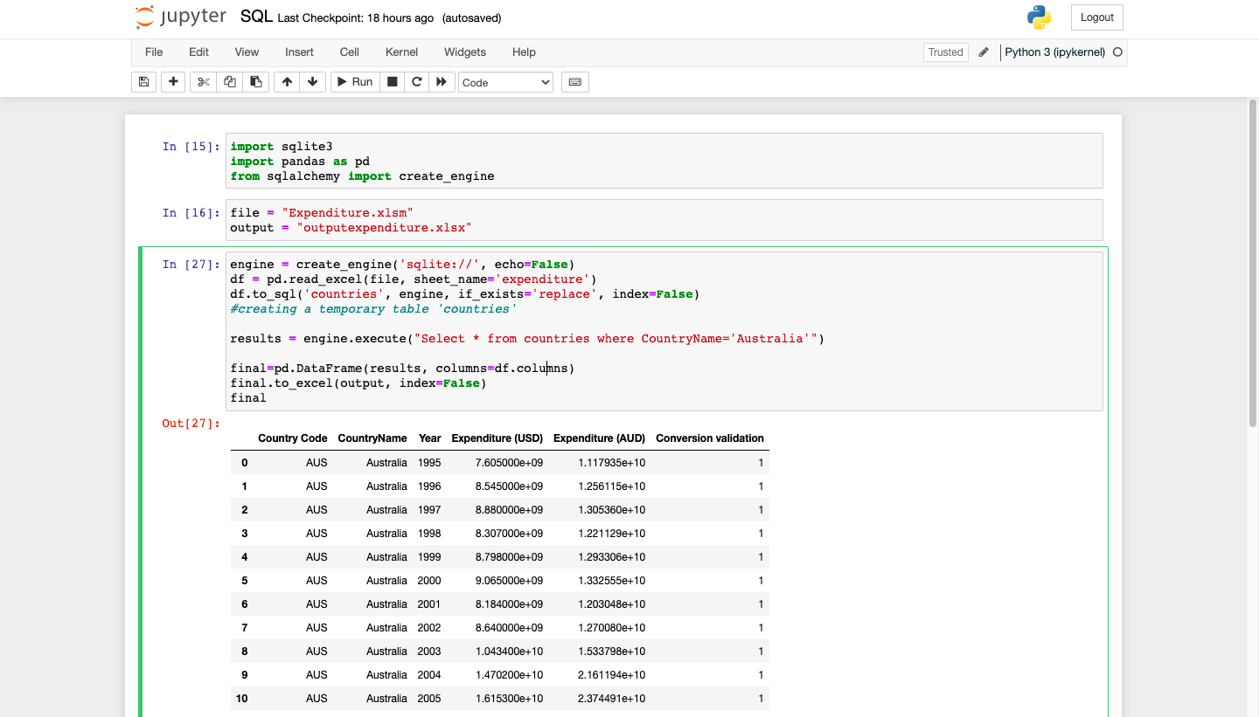

*Screenshot of Jupyter Notebook and SQL/Python code*

These tools were explored and experimented with, however they were not required in the end since queries could be made withing the Tableau software.

### Microsoft Visual Basic

Why it was used

* The data downloaded from the World Bank could not be used in Tableau because each year was defined as a dimension instead of a measure.
  + Dimensions: qualitative data, discrete, usually placed in the columns
  + Measures: quantitative data, continuous,
* Graphical user interface, application, table, Excel

  Description automatically generatedIn order to make a time series, the table had to be set up so that each data value was a plottable data point on an x and y axis.



*Original data*

How it was done:

* Manually transposing the table using ‘paste special à transpose’ would take too long, so instead a macro was recorded, then the code was further modified to run for the entire table.

Macros code:

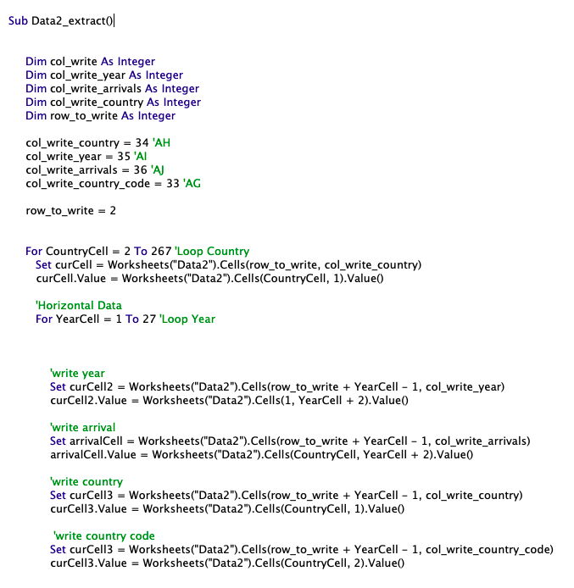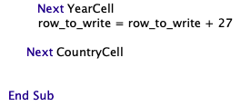

# Visualization Development Journey

Software used:

* Figma (online tool)
* Tableau

### Figma

Figma was used to for UI design of the visual solution. This is the first time using the software, however, it was fairly easy to use since most functions were self-explanatory and there were lots of YouTube tutorials.

The designs were exported as a png and imported onto the Tableau dashboard as a background image.

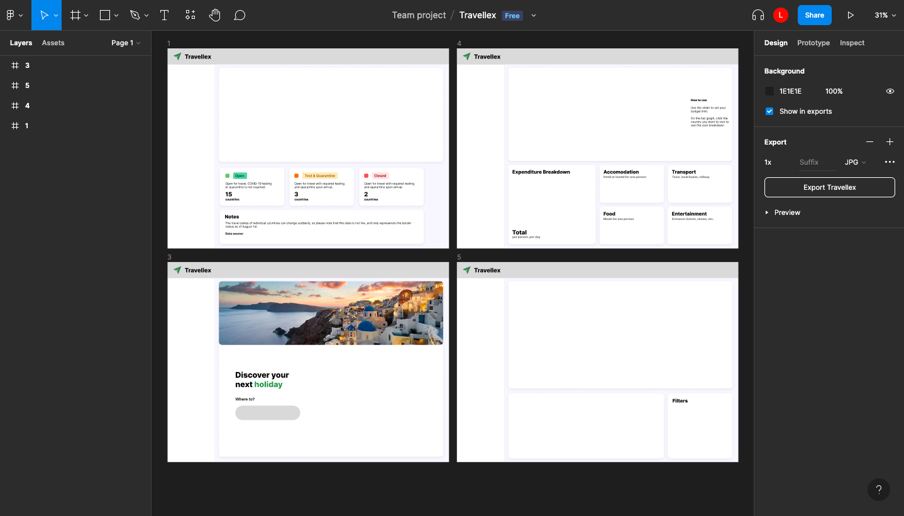

*Screenshot of Figma dashboard*

### Tableau

Tableau was used to develop the dynamic visual. This software required more research to learn how to use its functions; mostly using its official Tableau Help website as a guide.

<https://www.tableau.com/support/help?_ga=2.176344485.1643722940.1661681178-1385601293.1654741844>

All technical issues that arose, (e.g. invalid references to data, incorrect depictions of data, etc.) were solved also with the aid of the Tableau Help website.

# Formal Testing Results

## Dynamic Features (on the visual)

|  |  |  |  |  |
| --- | --- | --- | --- | --- |
| What was tested | How it was tested | Expected Result | Actual Result | How it was fixed |
| Page navigation buttons | Each button was clicked on each page/dashboard to see if the user was taken to the intended page | “Border Status” 🡪 border status page  “Budget Calculator” 🡪 budget calculator  “Best time” 🡪 best time  “Home Page” à home page | “Border Status” 🡪 border status page  “Budget Calculator” button didn’t work on the homepage  “Best time” 🡪 best time  “Home Page” à home page | Navigation settings was set to the budget calculator page. |
| Drop down menu on home page | Multiple countries were selected from the dropdown menu | The map should zoom into the country selected in the dropdown | The map zoomed into the country selected in the dropdown | N/A |
| Pop up details | Mouse was hovered over the country | Pop up details should show a summary of the country when mouse is hovered over the country |  | N/A |
| Budget limit | The slider was set to different limits and the value of the lowest and largest value was checked if within the limit | The slider should only show the countries with daily expenses within the set limit | The lowest and largest values were witin the set slider limits | N/A |
| Cost breakdown number displays | A country of the bar chart is selected, and the expense breakdown numbers were compared to the database values | Should change/represent the correct expense breakdown of the selected country when it is clicked on the bar chart | All values matched the database for the 5 countries tested. | N/A |
| Month dropdown filter (on ‘best time’ page) | All months were clicked, and the ‘Country Rainfall Comparison’ chart was observed | As a month is selected, the ‘Country Rainfall Comparison’ chart should change, and the order precipitation maintains its small to large arrangement | Values of the bar chart changed for each month, and maintained a small-to-large arrangement for all months | N/A |
| Country name filter | 5 countries were selected, and the ‘Monthly Rainfall’ chart was observed | As a country is selected, the ‘Monthly Rainfall’ chart values should change | Values of the ‘Monthly Rainfall’ chart changed for each of of the 5 countires selected. | N/A |

## Structural Database Testing Results

|  |  |  |  |  |
| --- | --- | --- | --- | --- |
| What was tested | How it was tested | Expected Result | Actual Result | How it was fixed |
| Check for presence of Primary and Foreign Keys | Through observation | Primary key: there should a common field between all sheets  Foreign keys: field names should be different between each sheet | Country_Name is a primary key since it’s present in all sheets  Foreign Keys – each field has a different name | N/A |
| Data type of the primary key and the corresponding foreign keys are the same in the two tables | Through observation | Month = “Time”  Country_Name = “General”  Year = “Time”  Expenditure = “Currency”  Precipitation = “Number” | Month = “Time”  Country_Name = “General”  Year = “Time”  Expenditure = “Currency”  Precipitation = “General” | Precipitation was changed to “Number” format |

## Testing Queries

|  |  |  |  |  |
| --- | --- | --- | --- | --- |
| What was tested | How it was tested (data) | Expected Result | Actual Result | How it was fixed |
| A-Z sort on country name | Country_Name field | All countries should be in alphabetical order (A-Z) | All countries were in alphabetical order | N/A |
| Filter function (per column) | All data will be unselected, then  Approach 1: Each checkbox will be individually clicked  Approach 2:  2-3 boxes will be selected at a time | The column should only show data clicked by the checkbox. | All checkboxes were functional – all showed the corresponding data | N/A |

## Testing Formatting and Conventions

|  |  |  |  |  |
| --- | --- | --- | --- | --- |
| What was tested | How it was tested | Expected Result | Actual Result | How it was fixed |
| Naming conventions have been followed for all fields | Observation | All fields should follow a combination of snake and camel casing naming conventions | One field on the ‘Border Status’ sheet did not have capital letters (border_stat) | Capital letters were added to the start of each word 🡪 (Border Stat) |
| Table formatting is consistent throughout all sheets | Observation | All tables should have:  A black header, primary in the first column, field titles in bold | All tables had the correct formatting | N/A |

## Testing Formulas and Calculations

|  |  |  |  |  |
| --- | --- | --- | --- | --- |
| Input | Process | Expected Output | Actual Output | How it was tested |
| Expenditure (USD) | =Expenditure (USD) * 1.44 | Expenditure (AUD) | Expenditure (AUD) | Manually inputted into calculator, matches corresponding cell value |
| Exp_Transportation, Exp_Accomodation, Exp_Food, Exp_Entertainment | = SUM(Exp_Transportation, Exp_Accomodation, Exp_Food, Exp_Entertainment) | Expenditure Total | Expenditure total | Graphical user interface, text  Description automatically generated  Manually inputted into calculator, matched the corresponding cell value |

## Testing Data Visualisations (Miscellaneous)

|  |  |  |  |  |
| --- | --- | --- | --- | --- |
| What was tested | How it was tested | Expected Result | Actual Result | How it was fixed |
| URL Links | Link will be clicked | Should take the user to the intended website | The solution with the intended page is opened using the link | N/A |
| Brower compatibility | Multiple different browsers are used to open the solution | Should be accessible on multiple browser types | A variety of browsers were able to successfully host and perform required tasks in the solution | N/A |
| Device compatibility | Different devices open the solution | The solution should be functional on different devices | The solution opens and works on different devices, yet the formatting is only suited for desktop | This is unable to be fixed, as the formatting issue is a problem with the Tableau website, and not the solution itself |
| Shared link of the public server (Tableau) | Search up the name of the solution on the Tableau public website | Should find the solution from an organic search | The solution is found when organically searching the title on the the public Tableau website | N/A |

Testing Readability

|  |  |
| --- | --- |
| Criteria | Tick |
| Is the text large enough to read comfortably on a small device? | No |
| Is contrast optimal, or at least satisfactory? | Yes |
| Is the typeface a readable size? | Yes |
| Are line or paragraphs of a good length? | Yes |
| Is text alignment attractive and readable on the page? | Yes |
| Are the spelling, punctuation, and grammar, correct? | Mostly (1 spelling error) |
| Is the vocabulary appropriate and inoffensive? | Yes |
| Is expression clear and unambiguous? | Yes |
| Are headings clear, and do they divide content into logical sections? | Yes |
| Are all the charts and pages appropriately labeled? | Yes |





Things that were removed:

* Website development
* Primary data collection

*Had forgotten to create testing tables during the design stage, therefore it had to be done during development.*

*The development stage was extended for approx. week*

*The design stage was shortened by approx. a week*

*Secondary data collection was done during the development of the visuals because initial collected data was lacking in relevant data to the solution*

*Some of the analysis and design tasks had to overlap due to time constraints*

# Changes to Gantt Chart

This Gantt Chart represents the actual timeline of the project.

## Changes to solution requirements

The original plan for the solution requirement was to include 50 countries in the final development. However, due to time constraints, it was decided that only the top 20 most travelled to countries would be chosen

## Changes to databases used

Instead of monthly arrivals to determine the best time of the year to visit a country, precipitation (rainfall) data was used as an alternative. Arrival number for each country was only given per year, not per month. The precipitation data was derived from the World Bank Climate Change Knowledge Portal.

Instead of using expenditure data from the World Tourism Organisation, data was extracted from the World Bank since it had a wider range of years and countries available. This data was used to depict the total tourism expenditure of a country at a certain year.

Cost breakdown data was manually derived from the website Budgetyourtrip. This data source may not be as reliable as reputable organisations, however no other data could be found that contained the cost breakdown of travel (e.g. accommodation, transport, etc.)

Links to additional databases:

* <https://climateknowledgeportal.worldbank.org/country/australia/climate-data-historical>
* <https://databank.worldbank.org/source/world-development-indicators>
* <https://www.budgetyourtrip.com/countrylist.php>

## Changes to scope

Once again, the original plan of having 50 countries chosen for the final design ended up being lowered to 20 due to time constraints.

Due to data limitations, airfare comparisons were cut from the final solution, as the data required was unable to be found, and therefore manipulated

On a technical basis, the solution was also not completed on a website, such as WordPress, as it proved difficult to construct a website and place the required data where needed. In the end, it was better to develop the solution of Tableau, and connect it to a public server to share with others

## Self-Observations (Solution Requirements)

## Functional Requirements

|  |  |  |  |
| --- | --- | --- | --- |
| No | Requirement/Output | Met? | Comments |
| FR01 | Allows users to select the month they wish to travel to. | **Yes** | In the precipitation data collected, users can select the month/s they wish to travel in, and make their own decisions based on how much rain they’re willing to tolerate. |
| FR02 | Users can click on the 50 locations to view more details on that country | **No** | While users can click on certain countries to obtain more details about their selected option, we were only able to work with 20 countries instead of 50 |
| FR03 | Users can view an expenditure breakdown of their selected country | **Yes** | When a selected country has been clicked, the expenditure breakdown involves a pie chart explaining the expenditure for that country, along with numbers on the side explaining it in a more readable fashion |
| FR04 | Users can compare airfares between three airlines that travel to their country of choice. | **No** | Insufficient airfare data and more data searching could not be done due to time constraints. |
| FR05 | Show the border status of the 20 countries | **Yes** | The chosen 20 countries are highlighted on a map, having a represented colour to their border status |
| FR06 | Popup details should appear as user hovers the mouse pointer over a piece of data | **Yes** | Pop ups appear on some data pieces, extra information is shown about the related country when hovered over by the mouse pointer |
| FR07 | URL links to original data sources | **Yes** | URL links to data sources successfully opened to the |
| FR08 | Website can be accessed through organic Google search | **No** | The solution can only be accessed through a public share file link, making it difficult to be found organically on the internet. It also doesn’t help that a foreign exchange company also has the same name - Travelex |
| FR09 | Website page can be refreshed | **Yes** | Yes, though it takes a few seconds for the page to be usable |
| FR10 | Easy to use on different technologies | **No** | The formatting of the webpage on mobile phones is not suitable to use, causing some items to be much smaller than intended, making the pages difficult to use |
| FR11 | Compatible with multiple browsers | **Yes** | Edge: Works  Chrome: Works  Ecosia: Works  Firefox: Works |

## Non-Functional Requirements

|  |  |  |  |
| --- | --- | --- | --- |
| No. | Requirement | Met? | Comments |
| NFR01 | **UI and visualizations should be clean** | Yes | Contrasting yet matching colours were used for the solution, with some colours chosen to match certain values that are relevant to real life. Titles are easy to view and don’t take up too much room on the webpages |
| NFR02 | **Is user-friendly** | Yes | From the results recorded from user testing, the overall answer was that solution was user-friendly |
| NFR03 | **Image components should have good resolution** | Yes | The images have a high-quality resolution, with pixels not even showing when zooming into the graphics |
| NFR04 | **Fast component response rate** | Yes | The components have a fast restore and response rate, though not fast enough to complete this requirement (was originally planning for 1.5s restore rate). When zooming in and out of graphs, it takes a few seconds for maps to reset themselves to fit the new size, and refreshing any webpage takes a while for the graphs to restore themselves |
| NFR05 | **Fast website load time** | No | The website during user testing had a mixed load time, with some responses being relatively fast and others taking well over 10 seconds for the page to fully load |
| NFR06 | **Primary data stored confidentially** | Yes | The primary data is unable to be accessed and altered through the website |
| NFR07 | **Data is reliable and acknowledged if from other sources** | Yes, technically | The data is acknowledged from other sources on some pages |
| NFR08 | **The information will follow the Australian Privacy Principles** | Yes | APP 1: The solution does collect and manage personal information  APP 2: The solution does not force users to make an account or give personal information in order to access the information provided  APP 3: The solution does not collect solicited information  APP 4: The solution does not collect nor manage unsolicited personal information  APP 5: The solution does not collect personal information, so there is no need to notify users on the website  APP 6: The solution does not hold personal information  In short, the solution doesn’t collect personal information, immediately following most of the APPs |
| NFR09 | **The graphs will be proportionate to the sizes required** | Yes | Countries on world maps are not uncharacteristically larger than their real-life counterparts, along with values in other charts resembling their values and being proportionate |

## Data Functional Requirements

|  |  |  |  |
| --- | --- | --- | --- |
| No. | Data requirement | Met? | Comment |
| FR12 | Number of international arrivals for each 50 countries | No | The data required to complete this requirement couldn’t be found, so this requirement couldn’t be completed |
| FR13 | Average airfares of outbound flights from Melbourne Airport | No | The data required to complete this requirement couldn’t be found, so this requirement couldn’t be completed |
| FR14 | Average tourism expenditure from that country | Yes | The solution contains the average expenditure from tourists in the solution, including a breakdown of what that average expenditure contains |
| FR15 | International border status of the 50 countries | Yes | Requirements of 50 countries were changed to 20 for time constraints, but the international border status as of 1/08 for those 20 countries have been recorded |
| FR16 | Forecast data of expected international arrivals from each country | No | The forecast data collected could only be found relating to Australia, and no other countries like intended, so this requirement could not be completed |

## Reliability Requirements

|  |  |  |  |
| --- | --- | --- | --- |
| No. | Reliability requirement | Met? | Comment |
| RR01 | Are the databases used relevant to the solution requirements? | Yes | Plenty of databases were added to the Excel workbook in the development, yet only those that were relevant to the requirements, or more accurate data sources were used in replacement. The data collected and used on the final design are all relevant to the requirements constructed and the original design |
| RR02 | Are the databases collected from a reputable source? | Yes | Most of the data collected come from organisations, many of which are known for their vast collections of accurate data |
| RR03 | Is the data formatted and stored correctly? | Yes | All the data collected and used are stored collectively on separate Excel spreadsheets, organised in relevant columns and rows. All data was manipulated into graphs on Excel |
| RR04 | Does the dataset include values for all fields? | Yes | Yes |
| RR05 | Is the data free from duplicates? | Yes | The data stored on the Excel spreadsheet have no duplicates for each value |

# Evaluation Tools

**Evaluation Criteria**

|  |  |  |  |  |
| --- | --- | --- | --- | --- |
| Criterion | Data required | Method | How it will be assessed | Judgement |
| Reliability (effectiveness) | Count of errors | Tally | Check for spelling and grammar mistakes, missing components, etc. | If fault count is under 5, then criterion is achieved. |
| Attractiveness  (effectiveness) | Peer opinions | Interview | Ask how visually appealing they find the app out of 5. Also ask for other opinions on the appearance | If average rating on aesthetic is above 4, and other opinions are 90% positive, then criterion is achieved |
| Usability (effectiveness) | Opinions, help count | Interview, tally | Count number of times they ask for help (indicates that solution is not intuitive)  Add up how many errors were made by users  Give users a questionnaire asking about their feelings regarding the solution’s usability. | If help was only requested once and users were able to use all functions within 5 minutes, then criterion is achieved.  If less than two errors occurred, then criterion is achieved |
| Accuracy  (effectiveness) | Peer observations | Tally | Log the number of complaints made by users (during user testing) about inaccurate information | If no complaints were made about any obvious inaccuracies of the visual, then criterion is achieved. |
| Security  (effectiveness) | Number of data breaches (from user testing) | Tally | Count the number of successful and thwarted attempts made to penetrate system database | If 2 attempts to penetrate database were successfully thwarted, then criterion is achieved. |
| Productivity  (efficiency) | Count of public views | Observation | Check the number of view the visual had received on the Tableau public server | If views are over 20 within month it was posted, then criterion is achieved. |
| Labour requirements  (efficiency) | Number of labour hours | Log | Count the number of hours spent maintaining the system | The solution shouldn’t require any maintenance once posted onto the tableau server |

## Interview Tools

Displeasing

**Aesthetics**

1 2 3 4 5

Pleasing

**Ease of use**

Difficult

1 2 3 4 5

Easy

**Navigation**

Difficult

1 2 3 4 5

Easy

**Overall functionality**

Dysfunctional

Functional

1 2 3 4 5

Interviews will be conducted in person – used online memo app to note down opinions

**Interview questions:**

What triggers would prompt you to use this website?

What features did you find most difficult to use?

What features you would like to add to the website?

How well does the website help with deciding where to travel to?

# Notes from user testing

Levina: Was meant to follow approach 2 but decided to explore instead

* Doesn’t read explanation of website, immediately looks at graphs
* Slow loading times noticed
* Looks at hyperlinked data sources (border status)
* Noticed a spelling error (represents)
* Manages to open data
* Noticed that Turkey doesn’t work on the budget calculator
* Managed to delete relevant graphs
* Plays around with filters available
* Attempts to delete graphs again
* Doesn’t understand colour gradient on precipitation graphs

Sharleen: Follows approach 1

* Chooses Italy as country to focus on
* Able to follow instructions given
* Finds all items wanted and required quickly and easily
* Uses different filters and parameters on the different graphs quickly and easily
* Doesn’t understand she can click on the budget calculator graphs
* Able to highlight chosen country on several different map graphs available

Maya: Explores

* Enjoys messing around with filters
* Able to use navigation button without it being pointed out
* Can use all different graphs with ease once given slight directions
* Deletes graph
* Uses multiple filters on the ‘when to go’ page to look at different values
* Manages to screw up the monthly precipitation graph values order (managed to get the year to start with May????)
* Deletes another graph
* Learns how to refresh page to return all graphs back to their original positions
* Decides to go ahead and delete Japan

# Interview Answers (Summarized):

**What triggers would prompt you to use this website?**

* **Person 1:** Trying to find a place to go on holiday
* **Person 2:** Working out holiday plans, or wanting to spur myself into a holiday idea
* **Person 3:** Wanting to go on holiday, and either work out where I want to go, or how much the trip will cost

**What features did you find most difficult to use?**

* **Person 1:** My eyes were drawn to the graphs and images on the page, where I didn’t spot the navigation buttons on the side, so I had trouble working out where to go
* **Person 2:** I found it all easy
* **Person 3:** Mainly the fact that I was able to delete the graphs

**What features you would like to change on the website?**

* **Person 1:** I’d like to see references to what the image is on the home page, as in either a link to the image, or a direct credit to the photographer themselves
* **Person 2:** The when to go page feels a little crowded with all the graphs, so I’d like to see it spread out more there
* **Person 3:** The text felt like it was more hidden away in some areas by the graphs, so I’d like to change the size of the text to stand out, so it’s easier to understand what the graphs mean

**How well does the website help with deciding where to travel to?**

* **Person 1:** I think it helps a lot
* **Person 2:** Well
* **Person 3:** Heaps

# Ratings

**Person 1: Levina**



Displeasing

**Aesthetics**

1 2 3 4 5

Pleasing

**Ease of use**

Difficult

1 2 3 4 5

Easy

**Navigation**

Difficult

1 2 3 4 5

Easy

**Overall functionality**

Dysfunctional

Functional

1 2 3 4 5

**Person 2: Sharleen**



Displeasing

**Aesthetics**

1 2 3 4 5

Pleasing

**Ease of use**

Difficult

1 2 3 4 5

Easy

**Navigation**

Difficult

1 2 3 4 5

Easy

**Overall functionality**

Dysfunctional

Functional

1 2 3 4 5

**Person 3: Maya**



**Displeasing**

**Aesthetics**

**1 2 3 4 5**

**Pleasing**

**Ease of use**

**Difficult**

**1 2 3 4 5**

**Easy**

**Navigation**

**Difficult**

**1 2 3 4 5**

**Easy**

**Overall functionality**

**Dysfunctional**

**Functional**

**1 2 3 4 5**

# Evaluation Results

## Evaluation Criteria Table

|  |  |  |  |  |
| --- | --- | --- | --- | --- |
| Criterion | Data required | Method | How it will be assessed | Results |
| Reliability (effectiveness) | Count of errors | Tally | Check for spelling and grammar mistakes, missing components, etc. | One typo was found (during user testing); fault count remains under 5 – criterion is achieved. |
| Attractiveness  (effectiveness) | Peer opinions | Interview | Ask how visually appealing they find the app out of 5. Also ask for other opinions on the appearance | Average rating of aesthetic was 4.3 – criterion is achieved since avg rating > 4 |
| Usability (effectiveness) | Opinions, help count | Interview, tally | Count number of times they ask for help (indicates that solution is not intuitive)  Add up how many errors were made by users  Give users a questionnaire asking about their feelings regarding the solution’s usability. | Help was asked/needed to be provided more than once – criterion was not achieved.  More than 2 errors were made on two user testing accounts – criterion was not achieved. |
| Accuracy  (effectiveness) | Peer observations | Tally | Log the number of complaints made by users (during user testing) about inaccurate information | No complaints were made about any inaccuracies of the visual - criterion is achieved. |
| Security  (effectiveness) | Formal testing  (attempts to access data) | Tally | Count the number of successful and thwarted attempts made to penetrate system database | 2/2 attempts to penetrate database were successfully thwarted (there was no way to access that project database through the website) - criterion is achieved. |
| Productivity  (efficiency) | Count of public views | Observation | Check the number of view the visual had received on the Tableau public server (indicates that the solution is somewhat interpretable and helpful) | View count = 185  Therefore, criterion is achieved. |
| Labour requirements  (efficiency) | Number of labour hours | Log | Count the number of hours spent maintaining the system | Maintenance hour = 0  Criterion is achieved. |

# Analysis of User and Formal Testing Data

A mixture of evaluation techniques was applied during this stage, from user testing and interviews, to comparing the solution to each functional requirement. The subjective evaluation, comparison of requirements, proved beneficial in checking whether each functional and non-functional requirement created in the planning stage ended up being included in the final solution, whilst the objective evaluation, such as interviews, was able to provide a more in-depth review of the usability of the solution, allowing us to work out what things were needed improvement.

In the rating charts from the user testing, all areas obtained a minimum of 4, except for navigation being rated a 3 by one of the user testers. This may have been influenced by the web page chart, where budget calculator can only be accessed while on the border status page, and vice versa. While not all the areas were rated a 5, based on comments and notes taken during user testing, non-functional and functional requirements seem to have been met.

Given that user testers had requested/were given help a few times during the user testing indicates that the usability of the solution has its deficiencies, hence ‘Usability’ criterion in the evaluation table was not achieved. Issues that arose include:

* Ability for user to delete data/graph from the interface
  + This problem could be solved by refreshing the page, therefore there were no breaches to the project’s database.
* Filters for some graphs did not work for certain countries
  + Didn’t show the correct gradient or alphabetical sorting.
* Missing data (some countries showed null values)

Nevertheless, an adequate number of functional and non-functional requirements were met through comparisons between the solution and previous requirements set, though some were not met in the final solution. FR02 was not met due to time constraints, where it was decided early in the development stage that only 20 countries would be analysed compared to 50. NFR05 was also not met during user testing, yet there are different factors that can influence this requirement, due to internet speed, age of computer and the working of the original Tableau domain. NFR07 was half met, where the data collected was reliable, yet was not acknowledged on every single webpage where secondary data was used. Therefore, due to the requirement not being specific enough, it’s difficult to remark whether NFR07 was met or not. Multiple requirements were not met due to similar contributing factors, where FR04, FR12, and FR13 were not met, as the data required to meet these requirements could not be found during the development stage. Meanwhile, FR08 and FR10 were not met due to the solution being developed on Tableau instead of constructing a website like originally planned, messing up the formatting on different devices and making it difficult to search for the solution organically on a search engine.

Despite these requirements not being met, most of the other requirements were met successfully and we were able to create a functional solution despite the time constraints. Therefore, the solution itself can be claimed as successful.

# Assessing the Project Plan

Overall, the Gantt chart allowed us to get a good indication on which stage of development we should be in and keep track of due dates, however tasks were not performed perfectly in line with the project plan.

It took longer than expected to acquire all the relevant data, as some were restricted from free public access, thus we needed to research elsewhere. Data collection was also done simultaneously with the visualization development, as better and more suitable data for the solution was found.

It also took longer than originally anticipated to develop the solution; thus the development stage was extended. Delays to the project timeline include the term 2 holidays, where not much work was done during that two-week period, and technical some issues with the Tableau software. User testing was also done too late within the timeline, therefore there wasn’t an opportunity to improve the visual solution upon the feedback given from the users.

In future projects, more time should be allocated to data collection and manipulation. It was not anticipated that lots and data cleaning was need. User testing should also be done at two points within the development stage: near the middle (after the 1st version of the solution had been developed), and near the end (where users test the improved and final version of the solution). In doing so, the usability of the project would have been better.

In the end, the deadlines were achievable, workloads were manageable between two people, and estimation of task allocations were fairly accurate. Therefore, it can be concluded that the project plan successful.

# Final Remarks

This project worked out quite well. In the design stage, we had made an overestimation of what could be achieved given the time period and intermediate knowledge of using data manipulation software. A significant portion of the development stage was spent researching and learning how to perform specific function for the visual. The collection of data also took longer than expected because it was difficult to find the relevant data, and large portion of time was spent cleaning and formatting for it to be usable in Tableau. As a consequence of a shorter development stage, not all the functional requirements were met.

Despite that, we are happy with the outcome of the dynamic visual solution. It has achieved its main purpose – that is to aid users into deciding which country to visit for their holiday. It is missing some features that we would’ve like to include, such as ____, and it’s usability is not as good as we want it to be, but nevertheless, it provided a good introduction to the skills and knowledge required for gathering/analysing data and developing useful visuals.